Project Design Phase
Problem – Solution Fit Template

Date | 8 September 2026
Team ID | SWUID2026190365
Project Name | ServiceNow-Based Employee Laptop Request Application
Maximum Marks | 2 Marks

Problem – Solution Fit Template:
The Problem-Solution Fit simply means that you have found a problem with your customer and that the solution you have realized for it actually solves the customer’s problem. It helps entrepreneurs, marketers and corporate innovators identify behavioral patterns and recognize what would work and why
Purpose:
- Solve complex problems in a way that fits the state of your customers.
- Succeed faster and increase your solution adoption by tapping into existing mediums and channels of behavior.
- Sharpen your communication and marketing strategy with the right triggers and messaging.
- Increase touch-points with your company by finding the right problem-behavior fit and building trust by solving frequent annoyances, or urgent or costly problems.
- Understand the existing situation in order to improve it for your target group.

Template:
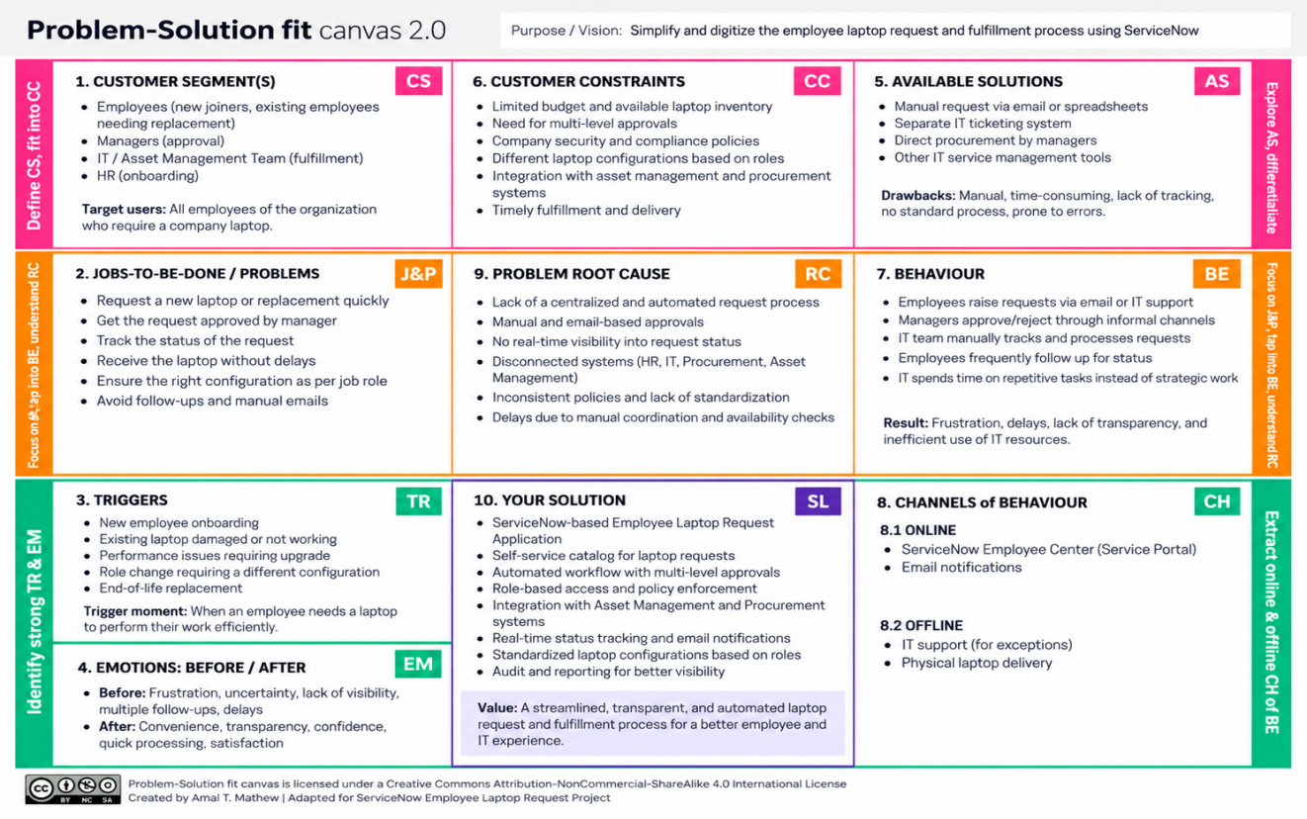
References:
- https://www.ideahackers.network/problem-solution-fit-canvas/
- https://medium.com/@epicantus/problem-solution-fit-canvas-aa3dd59cb4fe

Project Design Phase
Proposed Solution Template

Date | 8 September 2026
Team ID | SWUID2026190365
Project Name | ServiceNow-Based Employee Laptop Request Application
Maximum Marks | 2 Marks

Proposed Solution:
S.No. | Parameter | Description
 | Problem Statement (Problem to be solved) | Employees currently raise laptop requests through email or verbal communication. This makes requests difficult to track, approvals can be delayed, duplicate requests may occur, and there is no centralized view of request status.
 | Idea / Solution description | A ServiceNow-based Employee Laptop Request Application where employees submit laptop requests through Employee Center. Record Producer captures the request, Flow Designer automates manager approval, a Business Rule prevents duplicate requests within a year, ACLs provide role-based access, and email notifications inform the requester of approval or rejection.
 | Novelty / Uniqueness | The solution combines self-service laptop requests, automated manager approval, yearly duplicate-request prevention, role-based access control, status tracking, and automatic email notifications in one centralized ServiceNow application.
 | Social Impact / Customer Satisfaction | The system reduces employee frustration and repeated follow-ups by providing a simple centralized request process and clear status visibility. It improves transparency, accountability, and efficiency for employees, managers, and IT teams.
 | Business Model (Revenue Model) | The solution is primarily an internal enterprise application that reduces manual administrative effort, processing time, and operational costs. It can also be customized and implemented as a ServiceNow solution for other organizations.
 | Scalability of the Solution | The application can be extended to multiple departments and locations, different laptop categories, multi-level approvals, asset and procurement integration, employee onboarding, laptop replacement requests, dashboards, reports, and additional IT services.

Project Design Phase
Solution Architecture
Date | 8 September 2026
Team ID | SWUID2026190365
Project Name | ServiceNow-Based Employee Laptop Request Application
Maximum Marks | 4 Marks
Solution Architecture:
The solution architecture of the ServiceNow-Based Employee Laptop Request Application bridges the employee laptop request problem with a centralized ServiceNow technology solution. Its goals are to:
Find the best ServiceNow-based technology solution to centralize employee laptop requests and approvals.
Describe the structure and behavior of the ServiceNow application, workflow, access controls, and notifications.
Define features such as Employee Center, Record Producer, Flow Designer, Business Rules, ACLs, status tracking, and email notifications.
Provide specifications for managing, approving, tracking, and fulfilling employee laptop requests.
Solution Architecture Diagram:

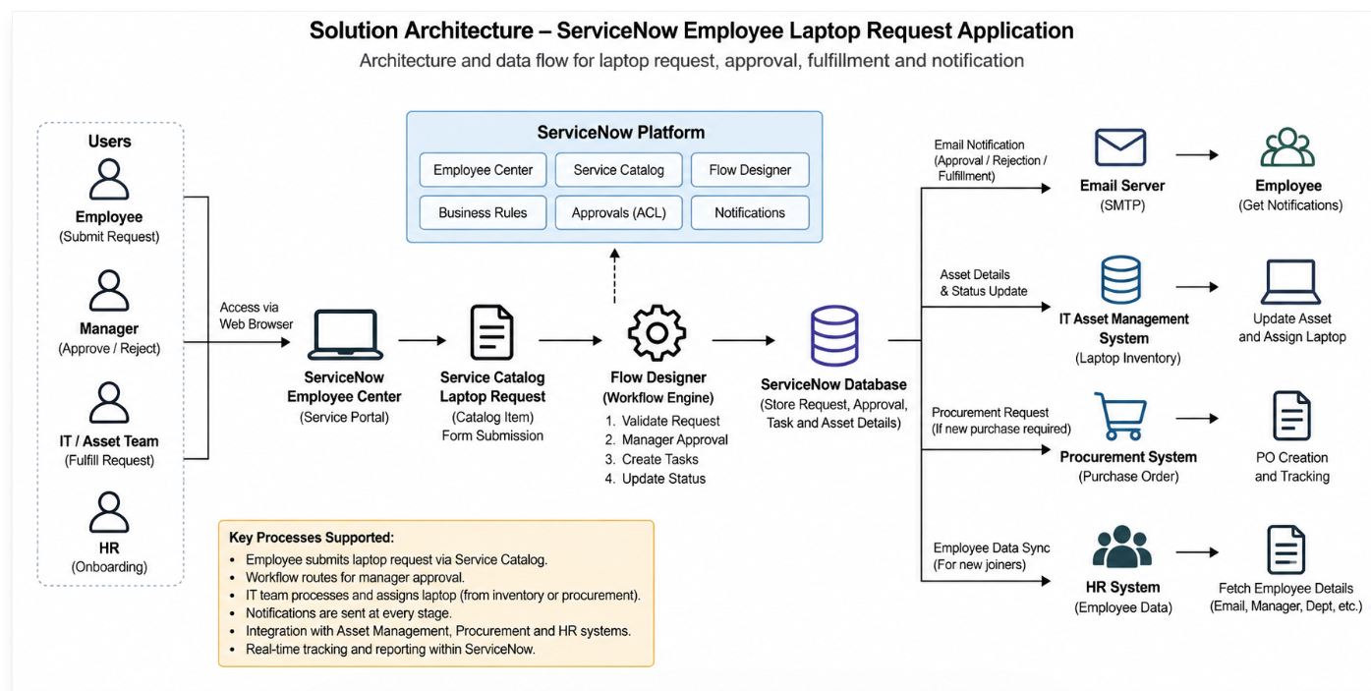

Figure 1: Technology stack architecture of the ServiceNow Employee Laptop Request Application
Reference: C4 Model – Software Architecture Diagramming

